MFM 1P WS 2.2 Exterior Angles of a Triangle NAME:
- a) For each exterior angle, name the opposite interior angles.
b) Write a relationship between the exterior angle and the opposite interior angles.
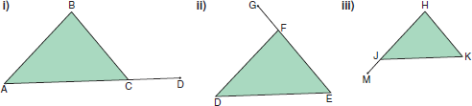

- Determine each unknown exterior angle.
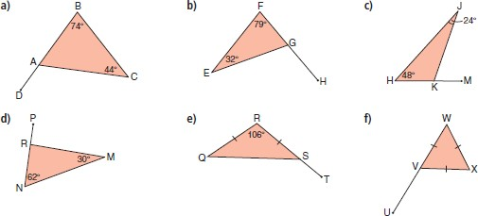

- Determine the unknown interior angles.
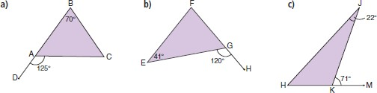

- A carpenter uses an L-square to measure the timber for a rafter. The ridge angle is 130°. What is the plate angle?
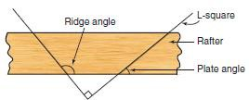
- Grace’s tech design class builds a model of a roof truss. The broken line is a line of symmetry. Determine the measure of each angle in the truss.
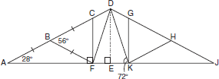

- Determine the angle measure indicated by each letter. Justify your answers.
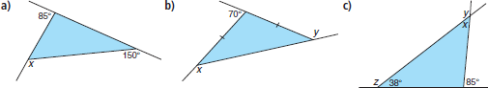

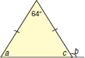
- Determine the angle measure indicated by each letter.
- Determine the angle measure indicated by each letter.
